UK Missing Persons Unit

Missing Persons
Data Report 2019/20

Date: 24th March 2021

Version number: 1.0

Leading the UK's fight to cut serious and organised crime

Index

 | Pages
Foreword | 3 - 4
Introduction | 5
Methodology and Data Limitations | 6 - 7
Executive Summary | 8 - 12
Key Statistics: Calls, Incidents and Individuals | 13 - 15
Demographics: Gender, Age and Ethnicity | 16 - 22
Risk | 23 - 28
Missing from Care | 29 - 30
Vulnerabilities | 31 - 33
Harm | 34 - 35
Duration Missing | 36 - 39
Who Finds Missing People? | 40 - 41
Reasons for Missing Incidents 42 - 45
Number of Long-term Missing Individuals | 46
Fatal Outcomes | 47
Unidentified Cases Notified to the UK Missing Persons Unit | 48
Glossary | 49 - 50

Foreword

We would like to thank police forces for providing data to the UK Missing Persons Unit (UK MPU) to enable the production of this report. It gives us an important insight into the scale and nature of missing behaviour and assists us to develop a partnership response to safeguard vulnerable people.

This report highlights that there are many different types of missing incidents that require different responses. Some young people run away from home and do not intend to return. Some adults make a conscious decision to leave home without informing those who are left behind. Others disappear unexpectedly with no obvious explanation creating concerns that they may have been a victim of a serious crime or may have suffered death or serious harm. Sometimes these individuals will remain missing for years causing huge distress for their loved ones left behind.

However, this report shows that disappearances and long-term absences only make up a small percentage of missing incidents reported to the police. Most individuals reported missing either return or are found within 48 hours. That does not mean that there is not a significant impact on police resources. Even if a missing person is located quickly, there can still be a significant police response. Some incidents require co-ordinated area searches and mobile phone checks because of concerns that the individual is vulnerable and unable to safely interact with their environment or because of concerns that they may take their own life or cause serious self-harm.

Other incidents attract an immediate police response because of concerns of exploitation. Although in most of these cases the individual has no intention of running away or leaving home, and they intend to return home later, the police have a duty to find them because of the risk they will suffer abuse and serious harm whilst absent. This can be challenging especially when the individual does not perceive themselves as a victim or does not want to be found. This therefore requires a partnership response over a sustained period to safeguard these individuals.

This report also helps us to identify variations in the reporting practices of partner agencies and differences in the recording policies of police forces. This is particularly apparent in respect of children reported missing from care. The Howard League for penal reform highlighted the harm caused by the premature reporting of children in care as missing when they are simply late home or have gone out without permission. Significant efforts have therefore been made to ensure professional carers undertake reasonable actions to locate a young person before reporting them missing to the police unless the circumstances suggest there is a real, immediate risk of the young person suffering significant harm. The Missing from Care Best Practice Guidance has been developed and is currently out for wider consultation. It contains the Philomena Protocol and the Levels of Intervention Model which seek to reduce the premature reporting of children in care as missing whilst still ensuring vulnerable children are safeguarded.
Another significant issue is the number of patients who leave acute and mental health hospitals who are reported as missing to the police. This issue was considered by the All Party Parliamentary Group who set up a Task and Finish Group to develop the Missing Adults Framework which was recently published. It seeks to promote a partnership approach to these incidents to ensure the most appropriate professional is able to provide the response.

Finally, I would like to thank all forces and our partner agencies for all your efforts during the last year in searching for missing people and supporting their families. I hope you will find this report both interesting and challenging as we strive to improve the partnership response to missing people and we seek to safeguard those who are vulnerable.



Catherine Hankinson
Assistant Chief Constable



Introduction

This report is the tenth in the series of data reports from the UK Missing Persons Unit (UKMPU) which have provided a rich picture of missing persons’ facts and figures since 2010.

The report contains data and an analysis describing missing persons for the financial year 2019/2020. Charts, tables and figures are used extensively throughout the report. In each of the section headings is a reference to the tables presented in the accompanying spreadsheet (in both excel and PDF format). The spreadsheet tables show the base data used to compile the many charts, etc. and used as grounding for the various analyses in the report.

A glossary of terms can be found at the back of the report and includes any type in italics.

As with all the previously published data reports, our statistical analysis is wholly reliant on the data being provided from forces. In some circumstances, forces have returned figures for data sets one year and then not the following; to get good quality data consistently on a yearly basis is challenging.

There are forces in E&W’s who’s missing persons systems simply do not allow them to extrapolate the data requested. Where possible, it is stated throughout the report the numbers of complete returns received for each breakdown. Following on from this, one police force reported a significant error in their returns for the 2018/2019 data report. The figures shown for 2018/2019 in this year’s accompanying statistical report are the revised figures.

Methodology and Data Limitations

This report provides an overall snapshot of missing persons reported to police forces in England, Wales, Scotland and Northern Ireland during the financial year 2019/20. A complete set of statistical tables accompanies this report. The tables cover all of the data collected in the 2019/20 Data Return, which was sent to 43 police forces in E&W (note that Warwickshire and West Mercia completed a combined return). Scotland also completed the return using a standard template of questions although their data was somewhat limited in comparison to most forces in E&W.

The 2019/20 Data Return consisted of a standard template of questions, which police forces throughout E&W and Scotland were asked to complete. The data for PSNI is drawn from the force’s own statistical report, published annually, which does not follow the same standard format. The data, therefore, is not entirely consistent but where possible, data extracts are included in this report.

The Data Return template asked police forces in England, Wales and Scotland to provide key statistics on missing person incidents during the financial year 2019/20 covering the following areas:

- Names of their Command and Control and Missing Person systems

- The numbers of Closing and Opening codes relating to missing persons

- The total number of incidents and individuals by person group, i.e. child or adult

- The total number of outstanding missing individuals as of 31st March 2020

- The total number of long-term missing individuals reported missing prior to the reporting period and who were still missing on the last day of the reporting period - that is, all individuals missing prior to 1st April 2019 and who were still missing on 31st March 2020

- Total numbers of incidents broken down by the following demographic groups: gender, age and ethnicity

- The number of incidents by risk assessments made, broken down by gender and person group - that is, child or adult

- The number of incidents flagged with Mental Health (MH) vulnerabilities or with a Child Sexual Exploitation (CSE) marker. These were split by gender and age or person group (i.e. adult or child)

- The number of incidents by the type of harm suffered and person group

- The total number of fatal outcomes of individuals who were reported missing

- The number of missing incidents by duration of time missing and person group
- The numbers of incidents resulting in the missing person being found and who finds missing people, by person group

- The number of incidents and individuals by person group, grouped by those that were identified as being in care or not

- Data from police forces is also collected on the reasons given for missing incidents by age group.

To ensure a degree of consistency across data tables, the UKMPU has made some adjustments or estimates in the total figures provided by police forces where necessary. These are produced by reviewing previous years returns, comparisons with any other data sets they have returned. These are indicated in the summary tables and the adjustments were mostly negligible.

The total number of incidents reported by a police force has been taken to represent a base, and any subsequent demographic breakdowns not matching this base have been topped up by adding under-reported figures into the unknown category. While excluding the unknowns from this analysis, they are still included in the tables to prevent any under-reporting.

The 2017 national guidance changed the classification of missing and absent categories with a four-tier risk continuum. However, some forces have continued to report absent and missing separately. Since the 2017/18 reporting period, these have been combined and are now reported as missing throughout this report.

While every effort has been taken to standardise the reporting of data to the UKMPU to allow for year-on-year comparisons, changes to reporting practices in some police forces mean that year-on-year comparisons in some areas should be considered with caution: where there are differences across years for a force, they are indicated as footnotes in the statistical report.

There are several other reasons why standardisation of reporting is limited, and these include:

- Police forces all operate with different systems, processes and procedures, and not all were able to provide data as required in the UKMPU’s Data Return

- Some police forces were unable to provide breakdowns by person group (adult or child) or by demographics (for example, age, gender or ethnicity). Hence there are differences in the total number of incidents, in particular tables C1-C5

- Some reporting in police forces may have resulted in duplication, and as highlighted above, reasonable adjustments may have been made to provide a degree of consistency

Executive Summary

This report provides an overview of missing person cases reported to the police during the financial year 2019/20.

The data used to produce this report has been taken from both police service command and control systems and missing person systems. Data has been obtained from 43 police forces in England and Wales (E&W). Data from Police Scotland and Police Service of Northern Ireland (PSNI) is provided where possible to give a fuller picture. This data, however, is not directly comparable as data collections, systems and processes differ from those in police forces in E&W.

Calls, Incidents and Individuals

- In E&W, there were 359,240 calls related to missing persons in 2019/20. This was a decrease of 6% (-23,720) compared to 2018/19 (382,960)

- In E&W, there were a total of 325,171 missing incidents reported in 2019/20 compared to 320,715 in 2018/19. This was an increase of 2% (5,440) in the total number of missing person incidents compared to 2018/19. These figures exclude those with an unknown age. (1171 and 921 for 2018/2019 and 2019/2020 respectively)

- In E&W, there were a total of 155,211 missing individuals reported in 2019/20 compared with 157,546 in 2018/19. This was an overall decrease by 1% (-2,335)

- In E&W, there were a total 65,800 missing children reported in 2019/20 compared to 67,853 in 2018/19. This was a -3% (-2,053) decrease. In comparison, the total number of missing adults remained almost the same at 89,128 in 2019/20 compared to 89,199 in 2018/19.

Demographics

- In E&W, 61% (198,943) of all missing incidents related to children and 38.7% (126,228) to adults. For the remaining 0.3% of incidents, data did not indicate whether the incidents related to a child or an adult

- In E&W, there was a minor decrease of 0.3% (-691) in missing person incidents relating to children compared to 2018/19. However, for adults, a more substantial increase of 5% (6,318) was seen compared to 2018/19

- As in the previous year, a common pattern across the UK was that there were more reported missing incidents involving males rather than females. This year in E&W, 57% (170,757) of all missing person incidents involved males, 43% (131,062) involved females. In E&W, there were 24,017 (7.4%) missing incidents that were reported with an unknown gender and these are excluded from the analysis. For Scotland, 57% (9,325) of missing persons reports were for males, while PSNI also reported 57% (6,506) of missing person reports were males.

- In E&W there were 319 transgender individual related missing persons incidents, 49 in Scotland and 20 in PSNI

- In E&W, when breaking down the total number of reported missing incidents (281,023) by age (see Table C2 of accompanying statistical tables), 3% (7,922 incidents) related to children aged 0-11 years; 60% (168,692 incidents) related to children aged 12–17 years; 23% (64,696 incidents) related to adults aged 18-39 years; 9% (26,541 incidents) to adults aged between 40-59 years; and 5% (13,235 incidents) to adults aged 60 years or more. These figures exclude 14% (45,132) of all reported missing persons incidents (326,155) as they were of unknown age

- In E&W, when missing incidents were broken down by ethnicity (see Table C3), 76% were recorded by police forces as White, 14% as Black, 5% as Asian and the remainder comprised smaller other ethnic minority groups. These percentages were calculated after excluding approximately 31% of all incidents that were reported as ‘Other/unknown’; these related to incidents for which police forces were unable to provide ethnicity data

- The Black ethnicity group was over-represented in the data at 14% compared with the general population of the UK at 3%. It is important to note that this national comparison may be skewed due to numbers reported in London, where there were 18,676 missing person incidents related to the Black ethnicity group. This represented 59% of all missing incidents (31,732) reported for this group in E&W

- In E&W, when reported missing incidents were grouped by gender and age (see Table C4), 66% (75,896) of all female missing incidents related to girls aged 12–17 years, compared with 56% (83,378) of all male missing incidents relating to boys aged 12-17

- Black and Middle Eastern males were more likely to go missing than females in the same ethnic group (Table C5 of statistical file). The ratio of male to female incidents was about 55:44 respectively for the White and Asian group, and 52:47 for the Chinese/Japanese/SE Asian group. However, for the Black ethnic group this ratio was 62:37, and for the Middle Eastern ethnic group it was 71:29

Risk

- Across the UK, most missing incidents were classified as Medium risk. In E&W, a total of 303,674 missing incidents were rated as follows: 12% (36,632) High, 64% (193,113) Medium, 10% (30,575) Low and 14% (43,354) were rated as No apparent risk. In Scotland, the distribution of risk rating as follows: 11% (1,840) High, 72% (11,840) Medium and 2,763 (17%) Low. For Northern Ireland, the distribution of risk rating percentages for missing investigations were 6% (421) High, 88% (5,911) Medium and 5% (355) at Low. Neither Scotland nor Northern Ireland use No Apparent Risk.

- In E&W, across all genders, there were more high and low risk incidents related to adults than children, and more medium risk incidents related to children than adults
Vulnerabilities

- In E&W, 9% (17,084) of all missing incidents involving children had a Child Sexual Exploitation (CSE) flag associated with them. Of these, 78% (13,379) involved girls, 21% (3,523) involved boys, 1% (177) were of unknown gender and 5 involved transgender children

- In E&W, 16% (20,777) of all adult missing person incidents (126,228) and 6% (12,477) of all child missing incidents (198,943) had a mental health flag attributed. For all the reported missing person incidents with a mental health flag, there was a female to male ratio of 43:57

- In E&W, among all missing incidents with a mental health flag, the ratio of men to boys was 64:36 and for women to girls the ratio was 53:47
Harm and Fatal Outcomes

- In E&W, nearly all reported missing cases (96%) resulted in no harm. There were more ‘no harm’ missing children incidents reported in total numbers and proportionally: 97% (78,089) of all missing children incidents were reported with no harm compared to 90% (30,367) of all adult missing incidents with no harm

- In E&W, missing adult incidents were three times more likely to result in physical harm and almost eight times more likely to result in self-harm than missing children incidents. Sexual offences related to missing incidents were low for both adults and children.

- In the UK overall, there were 955 reported fatal outcomes for missing persons in 2019/20 compared with 901 in 2018/19. This is a 6% year-on-year increase continuing the 5% increase seen in 2018/19.

Duration and Who Finds Missing People

- Most missing person incidents were resolved within 2 days of being reported: 84% in E&W and 98% in Northern Ireland. In Scotland, 75% of missing people were found within 1 day and 97% within 7 days

- In 2019/20 in E&W, 43% of missing children returned home voluntarily compared to 30% of missing adults. Police found children in 24% of missing incidents compared with finding adults in 42% of missing incidents. Family, guardians or carers found children in 11% of missing incidents compared to 2% of adult missing incidents. The Carer/Local authority found children in 8% of child missing cases compared to 2% of adult missing cases. Friends/acquaintances found children in 1% of missing incidents compared with 2% for adult missing. For children, 13% of missing incidents were reported to be found by Other means compared with adults at 17%

Reasons for missing

- The information shown below should be considered as an indicator of the reasons for going missing, but the data supplied has significant limitations. Only 20 of the 43 police forces in E&W were able to supply this data. Furthermore, specific reasons for missing were provided for only 54% (79,389) of incidents. The remaining 46% (67,983) of incidents were reported with a reason of ‘Other’, ‘Declined’, ‘Unknown’ or ‘Errors’

- The top 10 reasons for people going missing by age and all groups are shown below:

A complete list for each age group can be found in tables 13 and 14 of this report (pages 43-45)

Long-term Missing and Missing from Care

- In E&W, there were 4,543 long-term missing individuals still missing on 31st March 2020. PSNI reported 57 long-term missing individuals as of 31st March 2020

- In E&W, for people missing from a care setting, 88% of incidents were related to children in 2019/20 compared with 92% in 2018/19. For adults, this was 12% in 2019/20 compared with 8% in 2018/19.

- In E&W, there were more missing person incidents, on average, per individual for those from a care setting than from those individuals outside of the care system. For children, there were 4.7 incidents per individual in a care setting, compared to 2.2 incidents per individual in a non-care setting. For adults, on average there were 1.7 incidents per individual in a care setting compared to 1.3 incidents per individual in a non-care setting.

Key Statistics: Calls, Incidents and Individuals (Tables A1-A3)

359,240
The total number of calls made to a police force in E&W regarding a missing person. A second successive year-on-year reduction of 6% in comparison with 2018/19 (382,960). This equated to 6.0 calls per 1,000 population in E&W.

325, 171
The total number of incidents created on a police force missing persons management system. 43 police forces in E&W provided data, showing a 1.7% increase compared with 2018/19 (319,544).

155,211
The total number of individuals recorded missing on a police force missing persons management system. 43^{g} police forces in E&W provided data, showing an overall reduction of 1% compared with 2018/19 (157,546).

Table 1: Calls made to police forces in England, Wales and Scotland and missing person incidents, 2015 – 2020

Financial Year | Total Number of Missing Calls in E&W | % Yearly Differences in Calls for E&W | Incidents in E&W | % Yearly Differences in Incidents for E&W | Total Number of Missing Calls in Scotland | % Yearly Differences in Calls for Scotland
2015/16 | 337,640 | 20% | 242,317 | 15% | 40,070 | 0%
2016/17 | 387,930 | 15% | 328,690 | 36% | 21,989 | -45%
2017/18 | 405,798 | 5% | 329,748 | 0% | 22,966 | 4%
2018/19 | 382,960 | -6% | 320,715 | -3% | 21,338 | -7%
2019/20 | 359,240 | -6% | 325,171 | 1.3% | 28,534 | 34%

Figure 1: Number of missing calls and incidents in E&W, 2015/16 – 2019/20

In 2019/20 there were 110 calls for every 100 incidents compared with 139 calls for every 100 incidents in 2015/16.

In 2019/20, despite the 6% (-23,720) reduction in the total number of missing related calls compared with the previous year, the total number of missing related incidents this year increased overall by 1.7% (5,627) compared with 2018/19. This was predominantly due to adult incidents which saw a 5% (6,318) increase in 2019/20 relative to 2018/19. Missing children incidents over the same period saw a drop of 0.3% (691). Despite this increase in adult missing incidents, 61% (198,943) of all reported missing incidents still related to children compared with 39% (126,228) related to adults. For 921 incidents the data did not indicate whether the missing person was a child or an adult.

In 2019/20, PSNI reported a total of 11,326 calls related to the number of missing persons reports, an increase of 5% (565) compared to 2018/19. This equated to 6 calls per 1,000 population in Northern Ireland. There was a 4% (222) increase in children missing persons reports compared with 2018/19 whilst for adults, the increase was negligible at 0.4% (24).

In 2019/20, Police Scotland had 28,534 calls relating to missing persons investigations, an increase of 34% (7,196) compared to 2018/19. This equates to 5 calls per 1,000 population in Scotland.

Figure 2: Numbers of missing individuals in E&W, 2015 – 2020

In E&W, the total numbers of individuals reported missing fell by 1% (-2,124) in 2019/20 compare to those reported in 2018/19. Furthermore, there was an overall 1% (-1,783) reduction in missing children whereas the number of missing adults remained almost unchanged (-71, -0.1%).

In 2019/20, PSNI reported a total of 5,620 missing individuals. These comprised 1,562 children and 4,058 adults. Between 2018/19 and 2019/20, PSNI reported a 5% increase in the number of missing children (73 individuals) and a 6% increase in missing adults (238 individuals).

In 2019/20, Police Scotland was unable to provide the breakdown by missing individuals.

Demographics: Gender, Age and Ethnicity (Tables C1 – C5 )

Gender (Table C1, Base = 302,138)

Table 2: Distribution of incidents in E&W by gender, 2017 – 2020

Year | Female |  | Male |  | Transgender |  | Total excluding Unknown |  | Total/% Unknown
Year | No | % | No | % | No | % | No | % | No | %
2017/18 | 136,729 | 43.6% | 176,439 | 56.3% | 230 | 0.1% | 313,398 | 100% | 16,350 | 5.0%
2018/19 | 117,899 | 43.8% | 150,407 | 55.9% | 583 | 0.2% | 268,889 | 100% | 51,826 | 16.2%
2019/20 | 131,062 | 43.4% | 170,757 | 56.5% | 319 | 0.1% | 302,138 | 100% | 24,017 | 7.4%

Across E&W, and as in previous years, there were more male missing person incidents reported in 2019/20: 57% (170,757) compared with 43% (131,062) female incidents.

Similarly, PSNI and Police Scotland also reported a greater number of male missing person reports/investigations than for females. PSNI had 57% (6,506) male missing reports to 42% (4,754) female missing reports. Police Scotland reported 57% (9,325) male missing person investigations compared with 43% (7,055) female investigations. A very small percentage was due to transgender individuals and unknown genders.

In E&W there were 45% (264) fewer missing incidents for Trans people in 2019/20 compared with the previous year. Police Scotland reported 0.3% (49) of all missing investigations related to Trans people. PSNI reported they had 20 Trans people cases, or 0.2% of all investigations.

In 2019/20, 7% (24,017) of all missing incidents in E&W were recorded with unknown gender. These have been excluded from the analysis above. These figures are significantly lower than 2018/19. These are highlighted in Table C1 of statistical file for the relevant reporting year.

Age (Table C2, Base = 281,023)

In E&W, with the exception of those aged 0-11 years and 18-39 years, there has been a similar pattern over the last three years in the age distribution of missing persons, with little variation within each age group.

Missing incidents for children aged 0-11 years, saw a year on year fall from 3.3% (9,2750) in 2018/19 to 2.8% (7,922) in 2019/20. On the other hand, those aged 18-39 years saw a year-on-year increase in missing incidents from 22.4% (62,166) in 2018/2019 to 23.0% (64,696) in 2019/20.

Table 3: Distribution of incidents of missing by age groups, 2017-2020

Age Group  by Country & Year | 0-11yrs |  | 12-17yrs |  | 18-39yrs |  | 40-59yrs
Age Group  by Country & Year | No | % | No | % | No | % | No | %
E&W 2017/18 | 11,532 | 3.9% | 179,260 | 60.7% | 62,095 | 21.0% | 28,190 | 9.5%
E&W 2018/19 | 9,275 | 3.3% | 165,932 | 59.7% | 62,166 | 22.4% | 27,286 | 9.8%
E&W 2019/20 | 7,922 | 2.8% | 168,629 | 60.0% | 64,696 | 23.0% | 26,541 | 9.4%
PSNI 2019/20 | 363 | 3.2% | 5,292 | 47.1% | 3,378 | 30.0% | 1,576 | 14.0%
Scotland 2019/20 | 785 | 4.8% | 9,650 | 58.7% | 3,352 | 20.4% | 1,805 | 11.0%
Age Group  by Country & Year | 60+yrs |  | Total  excluding  Unknown |  | Unknown |  | Total  including  Unknown
Age Group  by Country & Year | No | % | No | % | No | % | No | %
E&W 2017/18 | 14,152 | 4.8% | 295,229 | 100% | 34,519 | 10.5% | 329,748 | 100%
E&W 2018/19 | 13,478 | 4.8% | 278,137 | 100% | 42,578 | 13.3% | 320,715 | 100%
E&W 2019/20 | 13,235 | 4.7% | 281,023 | 100% | 45,132 | 13.8% | 326,155 | 100%
PSNI 2019/20 | 636 | 5.7% | 11,245 | 100% | 81 | 0.7% | 11,326 | 100%
Scotland 2019/20 | 836 | 5.1% | 16,428 | 100% | 5 | 0.0% | 16,433 | 100%

60% (168,629) of all missing incidents in 2019/20 were made up of children aged 12-17 years (excluding the unknown figures).

Adults aged 18-39 years were the second highest age group of those to go missing at 23% (64,696), followed by the 40-59 years group at 9.4% (26,541).

Ethnicity (Table C3, Base =223,689)

Table 4: Distribution of incidents in E&W by ethnicity and across years

Number & percentage of missing incidents by Ethnicity | White - North European |  | White - South European |  | Black |  | Asian
Number & percentage of missing incidents by Ethnicity | No | % | No | % | No | % | No | %
E&W 2017/18 | 196,105 | 77.8% | 7,811 | 3.1% | 32,019 | 12.7% | 12,714 | 5.0%
E&W 2018/19 | 180,264 | 77.9% | 6,886 | 3.0% | 29,896 | 12.9% | 11,260 | 4.9%
E&W 2019/20 | 170,819 | 76.4% | 6,283 | 2.8% | 31,732 | 14.2% | 11,591 | 5.2%
Number & percentage of missing incidents by Ethnicity | Chinese,  Japanese &  SE Asian |  | Middle  Eastern |  | Total excluding Other/Unknown |  | Total including Other/  Unknown
Number & percentage of missing incidents by Ethnicity | No | % | No | % | No | % | No | %
E&W 2017/18 | 888 | 0.4% | 2,414 | 1.0% | 251,951 | 100% | 329,748 | 23.6%
E&W 2018/19 | 826 | 0.4% | 2,289 | 1.0% | 231,421 | 100% | 320,715 | 27.8%
E&W 2019/20 | 700 | 0.3% | 2,564 | 1.1% | 223,689 | 100% | 326,155 | 31.4%

Whilst the majority of reports in E&W relate to those of White ethnicity, consistent with previous years, there has been a 1.5% reduction in those of White- Northern European ethnicity, and a similar increase (1.3%) in those of Black ethnicity.

As noted in previous years, Black ethnicity is over-represented at 14% compared with 3% in the general population. If we include the total number of unknown, Black ethnicity is still over-represented at 9.7%. In 2019/20, 23 forces in E&W had proportionally more missing incidents related to the Black ethnic group than the general population.

As the majority of these incidents were of unknown ethnicity, we have excluded them from the analysis, but shown them in Table 4

As in previous years, PSNI reported far lower levels of reports for those from ethnic minorities with nearly 89% of all missing incidents relating to White- North European ethnicity. Only 1.1% related to those of Black ethnicity, 0.4% to those of Asian ethnicity, 0.2% to those of Chinese, Japanese and SE Asian ethnicity and 8.9% recorded as Other/Unknown.

Ethnicity data for Police Scotland was unavailable.

Age and gender (Table C4, Base = 271,105)

In E&W, although the majority of reports related to those aged 12-17 for all genders, this was most pronounced for females, accounting for two thirds of all reports. The next most common age group was 18-39 years for all genders, but was particularly pronounced for Trans people, accounting for around one third of reports, compared to only one fifth of female reports and one quarter of male reports.

Figure 3: Gender distribution of missing person incidents in E&W grouped by age (Table C4, Base = 271,105)

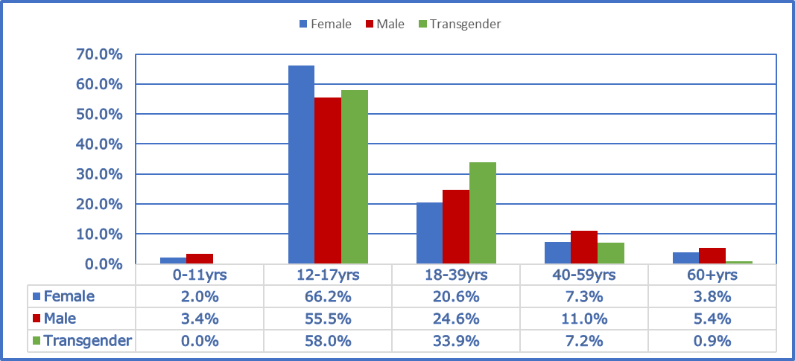

Figure 4: Age distribution of missing person incidents in E&W grouped by gender (Table C4, Base = 271,1050)

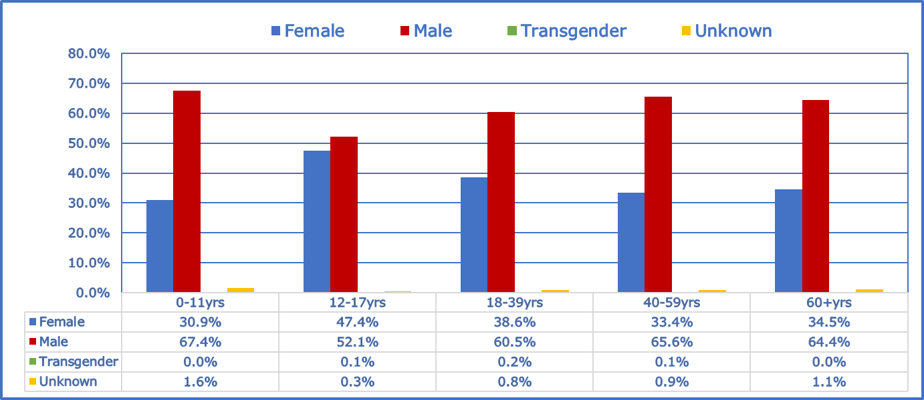

In E&W, the data is consistent with 2018/2019, showing more males reported missing in each age group.

Figure 5: Gender distribution of missing person reports in Northern Ireland grouped by age (Table C4, Base = 11,280)

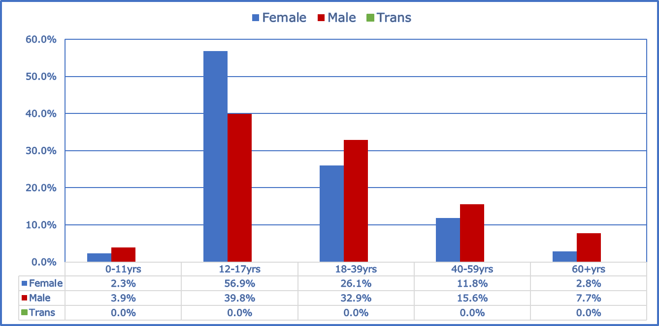

The data for females for PSNI followed a similar pattern to E&W with a substantial majority of reports relating to girls aged 12-17 years. There was, however, a less skewed distribution for males, with just under 40% of reports relating to boys aged 12-17 and approximately one third to men aged 18-39. There was no data available for Trans people

Figure 6: Age distribution of missing persons reports in Northern Ireland grouped by gender (Table C4, Base = 11,280)

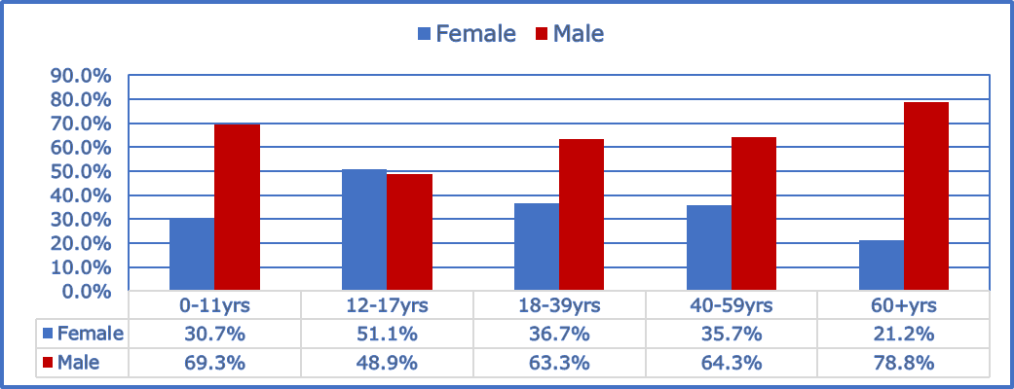

For PSNI, males were more likely to go missing than females in all age groups with the exception of children aged 12-17 years. For the 12-17 year olds, 51.1% (2,703) of missing person reports for girls compared to 48.9% (2,591) for boys.

PSNI also showed a more pronounced difference for the over 60 age group, there were almost four times as many reports relating to men compared to women 78.8% (501) and 21.2 %( 125) respectively.

Police Scotland was unable to provide this level of detail.

Ethnicity and gender (Table C5, Base = 271,105)

In Table 5, all incidents with unknown gender have been excluded from the analysis, but these unknowns are shown in Table C5 of the accompanying statistical tables.

For the White-North European, White-South European, Asian and Other/Unknown ethnicity groups, the ratio of the proportion of female to male missing incidents have remained about 44:55 over the last three years.

The ratio of the proportion of female to male missing person incidents for the Chinese, Japanese & SE Asian group has been constant since 2018/19, at about 47:52.

For the Black ethnic group, the proportion of male missing person incidents have increased by 5.4% since 2017/18.

For the Middle Eastern ethnic group, there was a 3% increase in missing male incidents between 2017/18 to 2019/20 with a corresponding reduction in female missing incidents.

The percentages of all missing person incidents reported with Other/unknown ethnicity had steadily increased from 13.8% (39,809) in 2017/18, 17.2% (47,109) in 2018/19 and 19.9% (54,080) in 2019/20. Whilst these figures are high across years, they have showed a similar distribution of females to males.

Table 5: Distribution of incidents by ethnicity and gender across years in England and Wales (these figures EXCLUDE unknown ethnicity figures, see table C5 of the accompanying statistical report)

Ethnicity (E&W) | 2019/20 |  |  |  | 2018/19 |  |  |  | 2017/18
Ethnicity (E&W) | Female % | Male % | Trans % | Total Incidents in E&W | Female % | Male % | Trans % | Total Incidents in E&W | Female % | Male % | Trans % | Total Incidents in E&W
White - North European | 44.4% | 55.4% | 0.1% | 164,302 | 44.9% | 54.9% | 0.2% | 175,960 | 44.7% | 55.2% | 0.1% | 191,085
White - South European | 42.8% | 57.1% | 0.1% | 6,173 | 45.7% | 53.7% | 0.6% | 6,826 | 41.5% | 58.4% | 0.1% | 7,744
Black | 37.5% | 62.4% | 0.1% | 31,235 | 39.3% | 60.6% | 0.1% | 29,621 | 42.9% | 57.0% | 0.1% | 31,669
Asian | 43.3% | 56.6% | 0.1% | 11,324 | 42.7% | 57.2% | 0.1% | 10,979 | 43.5% | 56.3% | 0.2% | 12,312
Chinese, Japanese & SE Asian | 47.2% | 52.8% | 0.0% | 680 | 47.5% | 52.3% | 0.1% | 810 | 51.6% | 48.1% | 0.3% | 865
Middle Eastern | 28.8% | 71.2% | 0.0% | 2,475 | 28.9% | 71.1% | 0.0% | 2,244 | 32.8% | 67.2% | 0.0% | 2,325
Other/ unknown | 43.6% | 56.3% | 0.1% | 49,164 | 43.4% | 56.2% | 0.4% | 42,445 | 43.2% | 56.7% | 0.1% | 38,729
Total | 43.2% | 56.6% | 0.1% | 265,353 | 43.8% | 55.9% | 0.2% | 268,884 | 44.1% | 55.8% | 0.1% | 284,729

Risk

When police forces in E&W receive calls regarding missing persons, the calls are assessed and assigned a risk category: high, medium, low or no apparent risk as set out in the College of Policing Authorised Professional Practice and as defined in the glossary.

Figure 7: Percentage of missing incidents in the UK by assigned risk assessments (Table D1, Base = 303, 674)

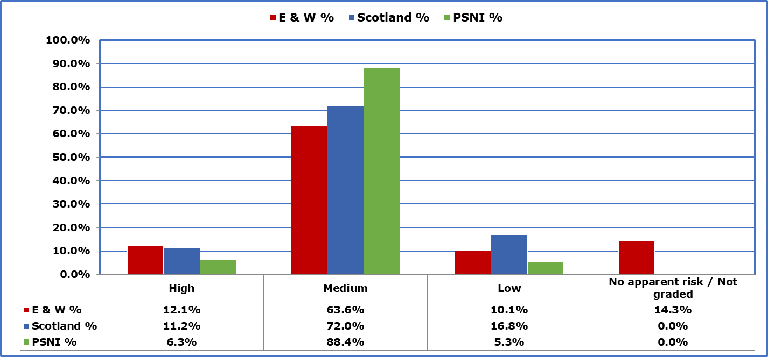

In E&W, 12.1% (36,632) of incidents were determined to be high risk, 63.6% (193,113) at medium risk and 10.1% (30,575) at low risk. This was based on data supplied by 42 forces (see Table D1 in the statistical file) and includes 14.3% (43,354) of all reported missing incidents that were assessed as ‘no apparent risk’ (previously the absent category).

For Police Scotland, 11.2% (1,840) of all missing person investigations were graded as high risk, 72.0% (11,840) as medium risk and 16.8% (2,763) as low risk.

PSNI also assessed most of their missing person reports to be at medium risk, at 88.4% (5,911). 6.3% (421) of all missing person reports were assessed as high risk, 5.3% (355) as low risk. .

Figures 8 – 10, show all missing person incidents by age within each gender group and how they are distributed across each risk category.

Figure 8: Distribution of risk ratings for all female incidents grouped by age in E&W (Table D2, Base = 108,304 )

Figure 9: Distribution of risk ratings for all male incidents grouped by age in E&W (Table D2, Base = 143,448 )

Figure 10: Distribution of risk ratings for all Transgender incidents grouped by age in E&W (Table D2, Base = 369 )

The patterns of distribution of missing incidents for each risk category and for each age and gender group, are remarkably similar to those seen in 2018/19. In 2019/20, we saw considerably fewer no apparent risk assessments for transgender children at 3.9% compared to 10.2% in 2018/19.

With the exception of transgender children in the low risk category, the patterns of distribution of incidents across genders at each risk level were quite similar.

Among all females, there were 13.9% (15,091) high risk missing person incidents, 70.3% (76,132) at medium risk, 8.5% (9,168) at low risk and 7.3% (7,913) assessed to be no apparent risk.

Of all the missing person incidents reported for males, there were 12.3% (17,678) high risk incidents, 65.4% (93,760) at medium risk, 12.3% (17,669) at low risk and 10.0% (14,341) assessed to be no apparent risk.

For all transgender individuals there were 369 incidents (excluding 2 record as unknown adult/child) reported, representing 0.1% of all incidents that were risk rated. These were split by 16.3% (60) as high risk incidents, 73.7% (272) as medium risk incidents, 5.4% (20) as low risk incidents and 4.6% (17) assessed to be no apparent risk.

Comparing risk by gender, both high and medium risk categories had proportionally more missing person incidents for females and transgender individuals than for males.

For the low risk category, proportionally there were more incidents for males than for females or transgender individuals. This was the same for the no apparent risk category.

Of the 303,674 reported missing incidents that were risk assessed, 48.4% (147,074) related to men and boys, 36.7% (111,316) to women and girls and 14.8% (44,913) were of unknown gender. 371 incidents related to transgender individuals.

Figures 11 – 13, show each risk category and the distribution of missing incidents by age within each gender group.

Figure 11: Distribution of female incidents by age, for each risk category in E&W (Table D2, Base = 111,316)

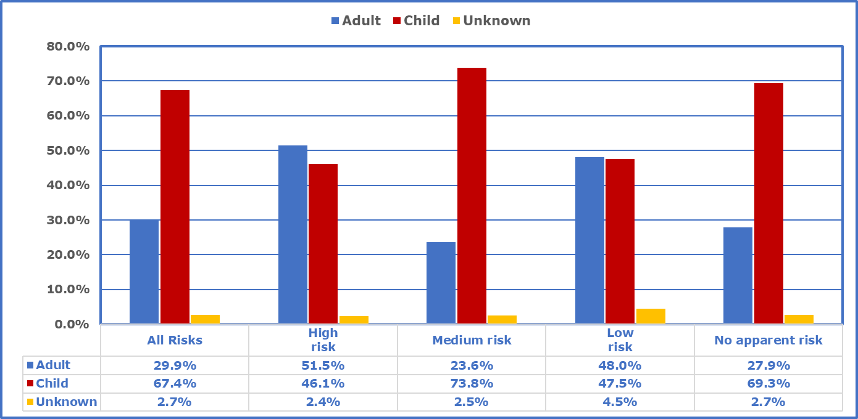

- Of all the risk rated missing incidents related to females, 29.9% (33,290) were attributed to women, 67.4% (75,014) to girls and 2.7% (3,012) were of unknown age

- Of all the female incidents risk rated as high, 51.5% (7,962) were attributed to women, 46.1% (7,129) to girls and 2.4% (368) were of unknown age

- At the medium level risk rating, women accounted for just 23.6% (18,446) of missing incidents at this level. However, there were considerably more incidents related to girls at 73.8% (57,686), with the remaining 2.5% (1,989) of incidents of unknown age

- Of all the female incidents risk rated as low, 48.0% (4,609) were for women, 47.5% (4,559) for girls and 4.5% (432) of unknown age

- Of all the missing incidents rated no apparent risk, 35.7% (8,136) related to just females. Of these, 27.9% (2,273) were attributed to women, 69.3% (5,640) to girls and 2.7% (223) were of unknown age.

Figure 12: Distribution of all male incidents by age, for each risk level in E&W (Table D2, Base = 147,074)

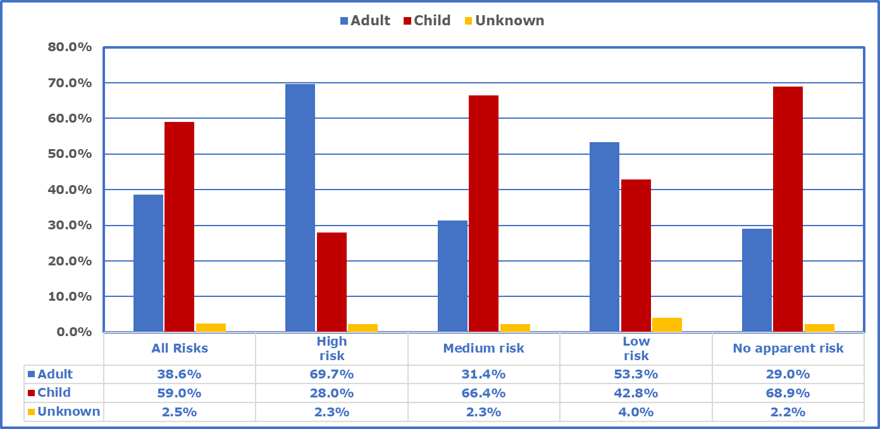

- Of all the male incidents that were risk rated, 38.6% (56,746) of these were attributable to men compared to 59.0% (86,702) to boys. 2.5% (3,626) of missing incidents were of unknown age

- When considering just the high risk incidents among males, 69.7% (12,612) were attributable to men compared with just 28.0% (5,066) to boys. There were also 2.3% (412) of incidents of unknown age in this group

- For medium level risk incidents, men accounted for 31.4% (30,085) of missing related incidents compared to 66.4% (63,675) for boys and 2.3% (2,163) of incidents were of unknown age

- Among males, for incidents rated low risk, men accounted for 53.3% (9,801) of missing incidents, compared to 42.8% (7,868) for boys, with 2.3% (734) of incidents where the age was unknown

- For male incidents considered to be of no apparent risk, there were 29.0% (4,248) attributable to men compared to 68.9% (10,093) for boys. There were also 2.2% (317) of incidents of unknown age in this group.

Figure 13: Distribution of all transgender incidents by age, for each risk level in E&W (Table D2, Base = 371)

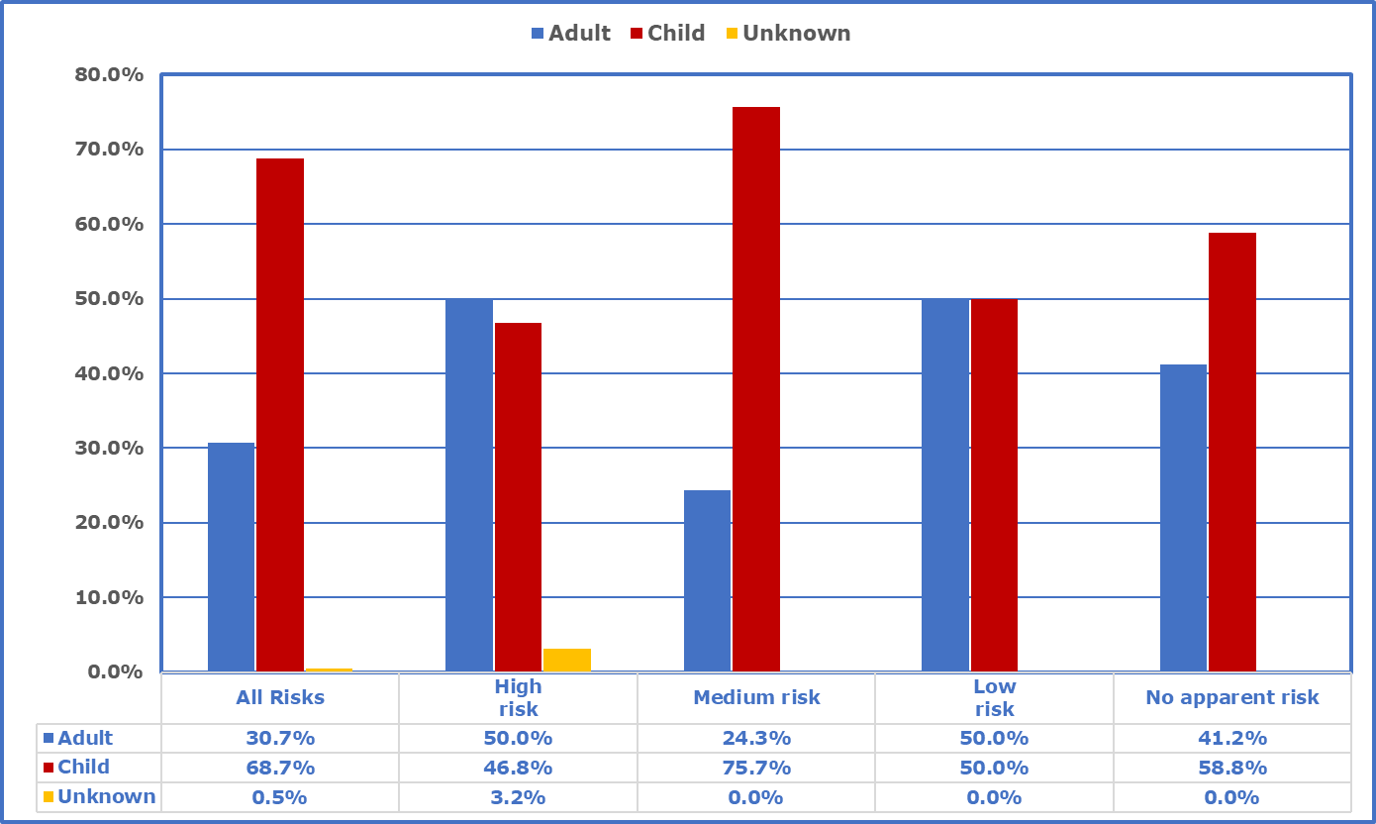

- For all risk rated missing incidents related transgender individuals in E&W, adults represented 30.7% (114) of incidents compared to children at 68.7% (255) of incidents. 0.5% (2) of incidents were of unknown age

- Of all the high risk rated incidents associated with transgender individuals, 50.0% (31) were for adults, 46.8% (29) for children and 3.2% (2) of incidents of unknown age

- For medium risk, the pattern was reversed, with adult incidents at 24.3% (66) compared to children at 75.7% (206)

- There were a small number of low risk incidents for transgender individuals, with both adult and children each at 50% (10) of all low risk transgender incidents

- No apparent risk incidents relating to transgender individuals were greater for children at 58.8% (10) compared with adults at 41.2% (7)

Missing from Care (Table F1)

The data in this section is based on full data supplied by 27 forces. As already highlighted, not all forces had systems or the reporting capability to provide this data. Forces that provided partial data have been excluded but are included in Table F1 of the statistical tables. By examining the ratio of total number of incidents to the total number of individuals by care status, we can ascertain how many incidents on average are attributable to repeat missing people.

Table 6: Total numbers of incidents and individuals by care status

2019/20 (27 Forces)

Incident / Individual | In Care | In Care % | Not in Care | Not in Care % | Grand Total
Incidents | 62,784 | 32% | 136,485 | 68% | 199,269
Individuals | 16,200 | 16% | 82,316 | 84% | 98,516
Ratio | 3.9 | - | 1.7 | - | 2.0

2018/2019 (29 Forces)

Incident / Individual | In Care | In Care % | Not in Care | Not in Care % | Grand Total
Incidents | 56,431 | 25% | 173,293 | 75% | 229,724
Individuals | 12,289 | 10% | 105,621 | 90% | 117,910
Ratio | 4.6 | - | 1.6 | - | 1.9

Of the total numbers of incidents provided by 27 forces, 32% of these were related to a care setting and represented 16% of all individuals who were reported missing during the year.

There was significant increase in the proportions of missing incidents related to individuals in a care setting between 2018/19 at 25% and 2019/20 at 32%. While the ratio of incidents to individuals has always been higher for individuals in care, 2019/20 saw a slight fall from 4.6 in 2018/19 to 3.9. This suggests that repeat missing incidents have fallen since last year and that there has been an increase in the numbers of missing incidents and individuals that were in care. It must, however, be considered that we have figures from just 27 forces for this data report, compared with 29 for 2018/2019.

For those not in care, there was little variation in the ratio of incidents to individuals as this was 1.6 in 2018/19 and 1.7 in 2019/20.

Table 7: Number of incidents and individuals by care status and person group

2019/20 (27 Forces)

Person | Incident / Individual | In Care | In Care % | Not in Care | Not in Care % | Grand Total
Adults | Incidents | 7,538 | 12% | 65,494 | 48% | 73,032
Adults | Individuals | 4,456 | 28% | 49,702 | 60% | 54,158
Adults | Ratio | 1.7 | - | 1.3 | - | 1.3
Child | Incidents | 55,246 | 88% | 70,991 | 52% | 126,237
Child | Individuals | 11,744 | 72% | 32,614 | 40% | 44,358
Child | Ratio | 4.7 | - | 2.2 | - | 2.8

2018/2019 (29 Forces)

Person | Incident / Individual | In Care | In Care % | Not in Care | Not in Care % | Grand Total
Adults | Incidents | 4,398 | 8% | 81,873 | 47% | 86,271
Adults | Individuals | 2,461 | 20% | 64,041 | 61% | 66,502
Adults | Ratio | 1.8 | - | 1.3 | - | 1.3
Child | Incidents | 52,033 | 92% | 91,420 | 53% | 143,453
Child | Individuals | 9,828 | 80% | 41,580 | 39% | 51,408
Child | Ratio | 5.3 | - | 2.2 | - | 2.8

For E&W, 88% of all reported missing person incidents for people in care were related to children.

For children in care, there were 5.3 incidents for each individual compared with just 2 for adults in care settings. This suggests that, on average, children in care had more repeat missing incidents.

For PSNI, there were 9.3 missing persons reports per each child in care, compared with 2.2 for those not in a care setting. For adults, this was 1.5 reports per individual in care to 1.3 reports for those not in care. There was no data available for Police Scotland.

Vulnerabilities (Table D3 – D5)

There are a range of vulnerabilities associated with going missing. In order to ensure an effective response when someone who is vulnerable goes missing, police forces add flags to records to highlight these factors. Due to system restrictions across forces, it is not possible to include a flag and capture data on all the vulnerabilities that are associated with cases of being missing and therefore this data report has focused on two deemed to be of particular interest; Child Sexual Exploitation (CSE) and mental health. The data used can be found in Tables D3-D5 of the statistical file.

Child Sexual Exploitation (CSE), Tables D3 – D4

Table 8: Number of missing incidents reported with CSE flags

CSE  in E&W | 2017/18  (32 forces) | % | 2018/19  (29 forces) | % | 2019/20  (38 forces) | %
Female | 16,002 | 70.2% | 12,392 | 69.1% | 13,379 | 78.3%
Male | 5,918 | 26.0% | 4,595 | 25.6% | 3,523 | 20.6%
Trans | 25 | 0.1% | 43 | 0.2% | 5 | 0.0%
Unknown | 841 | 3.7% | 910 | 5.1% | 177 | 1.0%
Total | 22,786 | 100.0% | 17,940 | 100.0% | 17,084 | 100.0%

Table 8 provides an overall scale of CSE in E&W that was reported to the UKMPU over the last three financial years. These data sets are not directly comparable as different numbers of forces provided data each year, as indicated by the figures in the brackets. The reported number of missing incidents with a CSE flag in E&W has clearly reduced from 22,786 in 2017/18 to 17,084 in 2019/20 with more forces providing data this year. This equated to about 9% of all missing children incidents (198,943) reported in 2019/20 in E&W.

Missing incidents for girls with a CSE flag appear to have shown a substantial increase from 69.1% (12,392) in 2017/18 to 78.3% (13,379) in 2019/20. However, it is important to note that this year we only have 1% of incidents (177) with a CSE flag and with unknown gender, compared with 5.1% (910) of unknown in 2018/19. This increase may therefore be attributable to improved recording and reporting. Additionally, in 2019/20, 20.6% (3,523) of all missing incidents with a CSE flag related to boys compared to 25.6% (4,595) in 2018/19, and just 5 incidents related to transgender individuals.

PSNI reported that there were 975 missing person reports with a CSE flag for 74 children. This equated to 13 missing person reports per child flagged at risk of CSE. A gender breakdown was not available.
Data on CSE was not available from Police Scotland.

Mental Health, Tables D3 – D5

Table 9 shows year on year comparative figures for incidents reported with a mental health flag.

There were 20,777 reported missing incidents for adults with a mental health flag. This represented 16.5% of all reported adult missing incidents (126,228).
For children, there were 12,477 reported missing incidents with a mental health flag. This represented 6.3% of all missing children incidents (198,948).

Table 9: Number of missing incidents reported with mental health flags

Mental Health in E&W | Adult
Mental Health in E&W | 2017/18  (29 forces) | % | 2018/19  (25 forces) | % | 2019/20  (33 forces) | %
Female | 7,193 | 37.4% | 6,067 | 38.0% | 7,712 | 35.9%
Male | 11,940 | 62.1% | 9,576 | 60.1% | 12,581 | 58.6%
Trans | 30 | 0.2% | 21 | 0.1% | 19 | 0.1%
Unknown | 68 | 0.4% | 282 | 1.8% | 1,124 | 5.4%
Total | 19,231 | 100.0% | 15,946 | 100.0% | 21,436 | 100.0%

Mental Health in E&W | Child
Mental Health in E&W | 2017/18  (28 forces) | % | 2018/19  (25 forces) | % | 2019/20  (33 forces) | %
Female | 4,400 | 40.1% | 3,730 | 52.3% | 6,824 | 48.9%
Male | 4,541 | 41.4% | 3,295 | 46.2% | 7,007 | 50.2%
Trans | 32 | 0.3% | 10 | 0.1% | 28 | 0.2%
Unknown | 1,991 | 18.2% | 94 | 1.3% | 107 | 0.7%
Total | 10,964 | 100.0% | 7,129 | 100.0% | 13,966 | 100.0%
In E&W, data provided by 33 police forces showed that missing incidents with a mental health marker could be divided by gender as follows: 43% (14,543) related to females; 57% (19,603) to males; and 0.1% (47) related to transgender individuals. These figures exclude 7% (2,716) of all incidents with a mental health marker that were recorded with unknown gender.

Among adults, mental health incidents were split between men at 62% (12,581) and women at 38% (7,712), excluding 5.1% (1,124) of incidents of unknown gender. For children, girls accounted for 49% (6,824) of incidents with mental health flags, while boys accounted for 50% (7,007). The remaining percentages were mostly due to unknown gender and a small number of transgender individuals.

No data was available on mental health related missing person reports for PSNI.

In Scotland there were 5,412 missing person investigations with a mental health marker. Gender or age breakdowns were not available.

Harm

The data for this section is included in the statistical tables E1-E2 in the accompanying file. It is based on responses from 25 police forces that were able to provide data broken down by harm suffered and age.

Table 10: Missing incidents by type of harm suffered in E&W)

Type | Child | Child % | Adult | Adult % | Unknown | Unknown % | Overall | Overall %
No Harm Suffered | 78,089 | 97.8% | 30,367 | 90.7% | 33,002 | 98.8% | 141,458 | 96.4%
Accidental Harm | 130 | 0.2% | 251 | 0.7% | 65 | 0.2% | 446 | 0.3%
Emotional Harm | 95 | 0.1% | 154 | 0.5% | 55 | 0.2% | 304 | 0.2%
Physical Injury | 786 | 1.0% | 1,069 | 3.2% | 65 | 0.2% | 1,920 | 1.3%
Self-Harmed | 491 | 0.6% | 1,533 | 4.6% | 168 | 0.5% | 2,192 | 1.5%
Sexual Offence Victim | 235 | 0.3% | 93 | 0.3% | 46 | 0.1% | 374 | 0.3%
Unspecified | 1,801 | - | 558 | - | 0 | - | 2,359 | -
Grand Total | 79,826 | 100.0% | 33,467 | 100.0% | 33,401 | 100.0% | 146,694 | 100.0%

In E&W, of all the reported missing person incidents with a harm outcome recorded (146,694), 96% were recorded as no harm suffered. Note that 8,421 incidents (from Cheshire and South Yorkshire) were excluded from the analysis as they were reported as “unspecified” indicating this was unknown.

Numerous other factors could also impact on harm associated with missing incidents (for example, environmental, social, health, financial, education, employment, cultural and criminality). Additionally, these figures should not be considered with respect to the total number of missing incidents, as multiple harm outcomes could have been reported for a single incident.

Overall order of harm is on a similar basis to 2018/19, that is, over 95% of incidents resulted in no harm.

Type of Harm Suffered, by Child or Adult

96.8% of all incidents relating to children were recorded as no harm suffered, down from 98% reported in 2018/19. A decrease can also be seen for adults with 93% in 2017/18 reporting as no harm suffered to 89.5% in 2019/20 (with 90% recorded as no harm in 2018/2019).

In E&W, there were a greater proportion of no harm suffered missing person incidents involving children (97.8%) compared with adults (90.7%).

In 2019/20, adults were three times more likely to suffer from physical injury compared to children, and a greater proportion of adult incidents were reported with self-harm (4.6%) than children (0.6%). These proportion have remained the same for both 2018/19 and 2019/20.

In 2019/20, adults were five times more likely to suffer from emotional harm compared to children. Additionally this year, the proportion of sexual offence victims in missing children and adult incidents were the same (0.3%).

While there were 39,680 missing incidents with no data by age, the majority of these (97.5%) were also recorded with no harm suffered.

No data was available on harm for either PSNI or Police Scotland.

Duration Missing

Duration missing is recorded by police forces as the time between when a person is recorded as missing by the police and when the police record that a person has been found or has returned. Data for this section is included in Table E4 of the accompanying statistical file.

Tables 11 and 12 summarises the reported total numbers and percentages of missing incidents in the UK, and the timeframes in which they occurred. They are based on data provided over the last two financial years from 29 police forces in E&W over 2019/20 and 31 police forces in E&W over 2018/19.

In E&W, there were significantly fewer missing incidents resolved in the first 8 hours in 2019/20 (43%) compared to 2018/19 (52%). This pattern was the same for all 24-hour timeframes, with 95% of missing incidents resolved within 7 days in 2019/20 to 97% in 2018/19.

Other timeframes show;

- Percentage found within 24hrs fell from 78% in 2018/19 to 71% in 2019/20

- Percentage found within 48hrs fell from 88% in 2018/19 to 84% in 2019/20

- Percentage found within 7 days fell from 97% in 2018/19 to 95% in 2019/20

- Percentage found after a week increased from 3% in 2018/19 to 5% in 2019/20

For PSNI, there was a significant increase in the percentage of missing incidents resolved within the first eight hours of a report being taken. In 2019/20 PSNI reported they had found people in 76% of all missing reports in 0-8hrs compared to 57% of all missing reports over the same timeframe in 2018/19.

For other timeframes there were also similar improvements:

- Percentage found within 24hrs increased from 82% in 2018/19 to 93% in 2019/20

- Percentage found within 48hrs increased from 91% in 2018/19 to 98% in 2019/20

- Percentage found within 7 days increased from 96% in 2018/19 to 100% in 2019/20

In E&W, while there has been some deterioration in the proportion of missing individuals being found within a 24-hour timeframe, most missing people are found or return very quickly. Around 16% of people are still missing for more than two days in E&W. PSNI reported that only 2% were still missing after two days.

Table 11: Number of incidents in E&W and PSNI by time missing, 2018-2020

2019/20 (Table E4)
Duration Missing | Missing Incidents in E&W | E&W % | Missing Reports in PSNI | PSNI %
0-8hrs | 88,395 | 43.0% | 7,464 | 76.2%
8-16hrs | 34,506 | 16.8% | 1,137 | 11.6%
16-24hrs | 22,126 | 10.8% | 549 | 5.6%
24-48hrs | 26,804 | 13.1% | 440 | 4.5%
2-7days | 23,764 | 11.6% | 203 | 2.1%
7 - 27days | 7,352 | 3.6% | 0 | 0.0%
28+days | 2,417 | 1.2% | 0 | 0.0%
Total | 205,364 | 100.0% | 9,793 | 100.0%
Duration | E&W | E&W % | PSNI | PSNI %
Within 24hrs | 145,027 | 70.6% | 9,150 | 93.4%
Within 48hrs | 171,831 | 83.7% | 9,590 | 97.9%
Within 7 days | 195,595 | 95.2% | 9,793 | 100.0%
Over a week | 9,769 | 4.8% | 0 | 0.0%
Base | 205,364 |  | 9,793
2018/19
Duration Missing | Missing Incidents in E&W | E&W % | Missing Reports in PSNI | PSNI %
0-8hrs | 119,386 | 52.4% | 5,622 | 56.5%
8-16hrs | 36,244 | 15.9% | 1,754 | 17.6%
16-24hrs | 21,364 | 9.4% | 737 | 7.4%
24-48hrs | 23,715 | 10.4% | 907 | 9.1%
2-7days | 20,319 | 8.9% | 575 | 5.8%
7 - 27days | 5,739 | 2.5% | 364 | 3.7%
28+days | 1,275 | 0.6% | 0 | 0.0%
Total | 228,042 | 100.0% | 9,959 | 100.0%
Duration | E&W | E&W % | PSNI | PSNI %
Within 24hrs | 176,994 | 77.6% | 8,113 | 81.5%
Within 48hrs | 200,709 | 88.0% | 9,020 | 90.6%
Within 7 days | 221,028 | 96.9% | 9,595 | 96.3%
Over a week | 7,014 | 3.1% | 364 | 3.7%
Base | 228,042 |  | 9,959

Due to a change in recording practices in Police Scotland comparison between 2019/20 and 2018/19 figures is not possible as shown in Table 12, however we were able to note the following:

- 75% of missing episodes were found within 24 hours in 2019/20 compared with 79% in 2018/19

- 97% of missing episodes were found within 7 days in 2019/20 compared with 98% in 2018/19 over the same timeframe

- 3.1% of missing investigation reports were resolved after a week in 2019/20 compared with 2.3% over the same timeframe in 2018/19

Figure 14: Duration of missing incidents in the E&W and PSNI by age

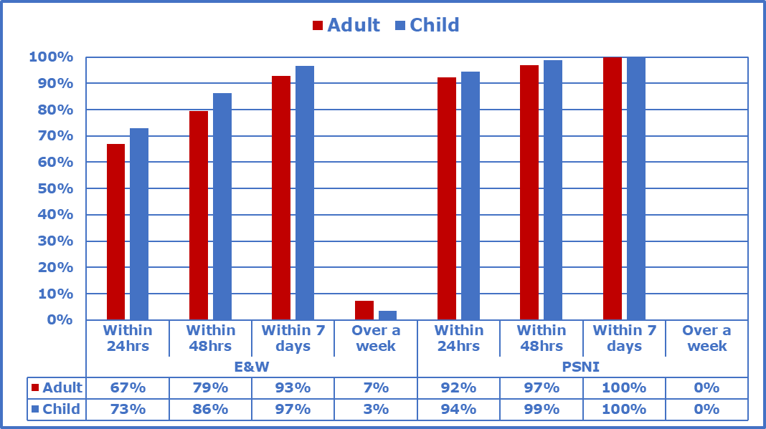

When looking at the percentages of missing incidents by duration and age, more children than adults were found or returned in all time frames within the first seven days.

Table 12: Number of missing investigation reports in Scotland by time missing, 2018-2020

2019/20 |  |  |  | 2018/19
Duration Missing | Scotland | Scotland % |  | Duration Missing | Scotland | Scotland %
0-12 hrs | 8760 | 53.3% |  | 0-8hrs | 9,748 | 45.7%
12-24 hrs | 3497 | 21.3% |  | 8-16hrs | 4,439 | 20.8%
2-7 days | 3684 | 22.4% |  | 16-24hrs | 2,555 | 12.0%
7-27 days | 415 | 2.5% |  | 24-48hrs | 2,569 | 12.0%
28+days | 87 | 0.5% |  | 2-7days | 1,535 | 7.2%
Total | 16443 | 100.0% |  | 7 - 27days | 367 | 1.7%
 |  |  |  | 28+days | 125 | 0.6%
 |  |  |  | Total | 21,338 | 100.0%
Duration | Scotland | Scotland % |  | Duration | Scotland | Scotland %
Within 24hrs | 12,257 | 74.5% |  | Within 24hrs | 16,742 | 78.5%
Within 7 days | 15,941 | 96.9% |  | Within 48hrs | 19,311 | 90.5%
Over a week | 502 | 3.1% |  | Within 7 days | 20,846 | 97.7%
Base | 16,443 |  |  | Over a week | 492 | 2.3%
 |  |  |  | Base | 21,338

Data for Scotland on missing investigations and their duration by age breakdown was unavailable.

Who Finds Missing People?

As highlighted in the previous section, most missing people are either found or return within two days. This next section looks at who finds missing people and large numbers of missing people return of their own accord.

The data in this section is reported in Table E5 of the accompanying statistical file.

Figure 15: ‘Found by’ categories of missing incidents in the E&W

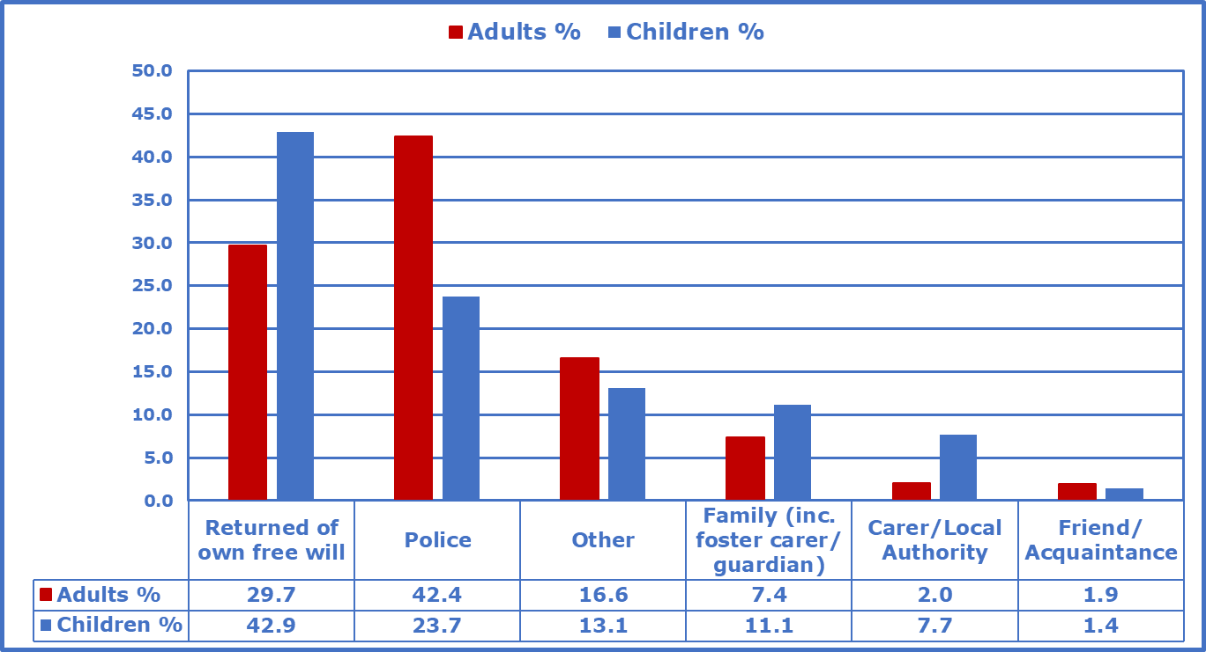

Of all the reported missing incidents related to children in E&W, in 43% of them children returned on their own free will. This was the largest group in the ‘found by’ categories for children. For adults, the percentage returning on their own was much lower at 30%.

In E&W, missing adults were mostly found by the police, and this was the case in 43% of all missing adult incidents. In contrast, police found missing children in 24% of all missing children incidents.

For missing children in E&W, 11% of incidents were resolved by family members or guardians, 7% by their carer or local authorities and 1% were found by friends or acquaintances.

For missing adults in E&W, 7% of incidents were resolved by family members or guardians, 2% by their carer or local authority and 2% by their friends or acquaintances.

In E&W, people were found by other means in 13% of missing children incidents, and 16% of missing adult incidents. Data on what this ‘Other’ category related to was unavailable.

Figure 16: ‘Found by’ categories of missing reports and investigations in PSNI and Scotland

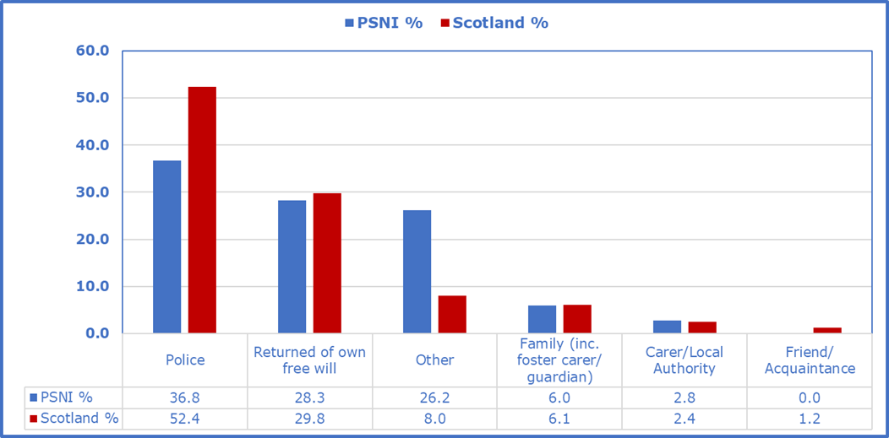

There was no data available by age breakdown for both PSNI and Police Scotland. However, overall numbers on “who found missing” were available.

For PSNI, police found most missing persons in 37% of reports, with 28% of missing persons returning home of their own free will. The Other category represented 26% of all found incidents, 6% of missing incidents were found by family members including guardians/foster carers and 3% by a carer or Local Authority.

In Scotland, police found missing persons in 52% of resolved investigations, with people returning of their own free will as the next largest group representing 30% of all resolved investigations. The ‘Other’ category represented 8% of found reports and 6% were found by family members including guardians/foster carers. Carer or Local Authority resolution of cases accounted for 2% of all missing person reports and friend/acquaintance at 1% of all missing reports.

Reasons for Missing Person Incidents

The data provided in this section was limited to 21 forces in E&W. The data comprised the number of missing incidents that had specific reasons for the missing episode, as set out in Tables E6 - E8 of the accompanying statistical file. Police had recorded these from prevention and return interviews once people had returned.

Of the 147,372 missing person incidents reported with a recorded reason, it was only possible to identify specific reasons for 54% (79,389) of these. Of the remaining 46% (67,983) that were unknown or unspecified, 61% (41,263) of these went missing due to other reasons not captured by the defined categories, 8% (5,262) declined to share their reason, 27% (18,157) were of unknown reason and another 4% (2,851) were due to errors or transfers to other police force areas. 426 incidents with unknown age were excluded from the analysis by age.

Reasons for missing, by age groups (Table E7)

Figure 17: Ranked percentages of all missing adult incidents with a reason

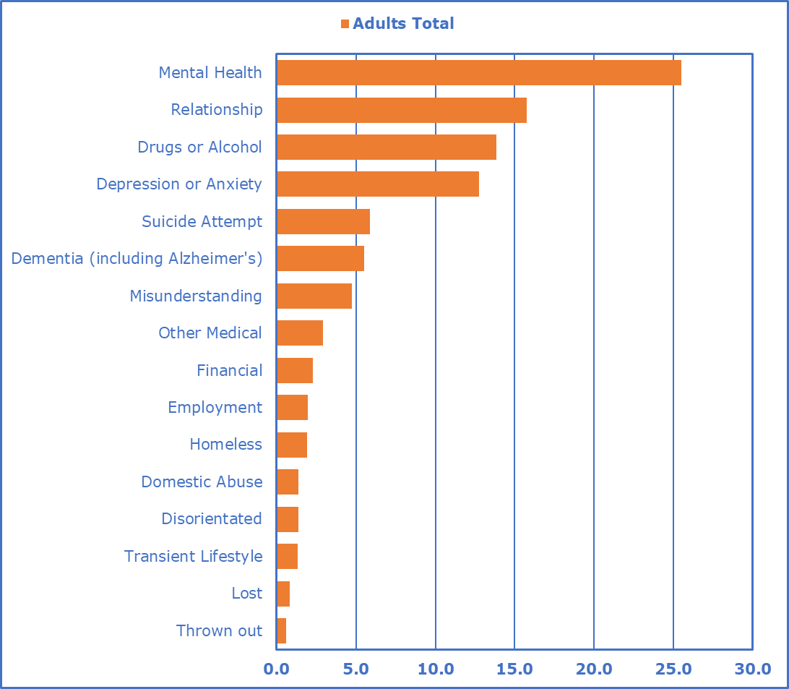

Table 13: Ranked percentage of missing incidents with a reason, adults
(Base= 38,949)

Reasons | Adults
Reasons | 18-39 years | 40-59 years | 60+ years | Total
Mental Health | 15.2 | 7.8 | 2.5 | 25.5
Relationship | 10.2 | 4.7 | 0.8 | 15.7
Drugs or Alcohol | 8.7 | 4.6 | 0.6 | 13.9
Depression or Anxiety | 8.0 | 4.1 | 0.7 | 12.7
Suicide Attempt | 3.7 | 1.8 | 0.4 | 5.9
Dementia (including Alzheimer’s) | 0.0 | 0.2 | 5.4 | 5.5
Misunderstanding | 2.9 | 1.2 | 0.7 | 4.8
Other Medical | 1.2 | 0.9 | 0.8 | 2.9
Financial | 1.2 | 0.9 | 0.2 | 2.3
Employment | 1.1 | 0.8 | 0.1 | 1.9
Homeless | 1.1 | 0.7 | 0.1 | 1.9
Domestic Abuse | 1.0 | 0.4 | 0.1 | 1.4
Disorientated | 0.3 | 0.3 | 0.8 | 1.4
Transient Lifestyle | 0.8 | 0.4 | 0.1 | 1.3
Lost | 0.2 | 0.2 | 0.4 | 0.8
Thrown out | 0.4 | 0.2 | 0.0 | 0.6
Injured | 0.2 | 0.1 | 0.1 | 0.3
School | 0.2 | 0.0 | 0.0 | 0.2
Forced to leave | 0.1 | 0.0 | 0.0 | 0.2
Unaccompanied juvenile | 0.1 | 0.0 | 0.0 | 0.1
Gang related | 0.1 | 0.0 | 0.0 | 0.1
County Lines | 0.1 | 0.0 | 0.0 | 0.1
Asylum seeker | 0.1 | 0.0 | 0.0 | 0.1
Sexual exploitation | 0.1 | 0.0 | 0.0 | 0.1
Abducted | 0.1 | 0.0 | 0.0 | 0.1
Honour Based Violence | 0.1 | 0.0 | 0.0 | 0.1
Trafficking | 0.0 | 0.0 | 0.0 | 0.0
Criminal exploitation | 0.0 | 0.0 | 0.0 | 0.0
Forced marriage | 0.0 | 0.0 | 0.0 | 0.0
Modern Slavery | 0.0 | 0.0 | 0.0 | 0.0
Female Genital Mutilation | 0.0 | 0.0 | 0.0 | 0.0
Terrorist offences | 0.0 | 0.0 | 0.0 | 0.0
All Reasons | 57.0 | 29.3 | 13.7 | 100.0

For adults, the most common reasons to go missing were found to be due to mental health at 25.5% (9,923); relationships at 15.7% (6,130); drugs or alcohol at 13.9% (5,401); depression or anxiety at 12.7% (4,961); suicide attempt at 5.9% (2,289); Dementia including Alzheimer’s at 5.5% (2,155) or misunderstanding at 4.8% (1,852). Collectively, these seven reasons represented 84% of all adult missing incidents with a specified reason.

With the exception of Dementia and Alzheimer’s, all of the above reasons were predominantly found in those aged 18-39 and then those aged 40-59 years.

Given most missing incidents were children aged 12-17 years, it is not surprising that most reasons (95.1%) were provided under this age group.

Figure 18: Ranked percentages of all missing children incidents with a reason

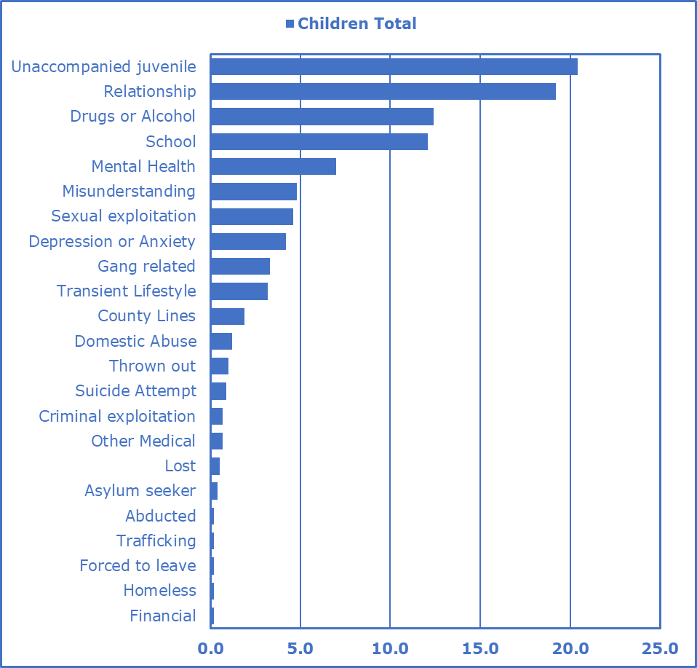

Table 14: Ranked percentage of missing children incidents with a reason, (Base = 40,440)

Reasons | Children
Reasons | 0-11  years | 12-17  years | Total
Unaccompanied juvenile | 1.2 | 19.2 | 20.4
Relationship | 0.8 | 18.4 | 19.2
Drugs or Alcohol | 0.1 | 12.3 | 12.4
School | 1.1 | 11 | 12.1
Mental Health | 0.4 | 6.5 | 7.0
Misunderstanding | 0.5 | 4.3 | 4.8
Sexual exploitation | 0.0 | 4.6 | 4.6
Depression or Anxiety | 0.1 | 4.1 | 4.2
Gang related | 0.0 | 3.3 | 3.3
Transient Lifestyle | 0.0 | 3.1 | 3.2
County Lines | 0.0 | 1.9 | 1.9
Domestic Abuse | 0.1 | 1.0 | 1.2
Thrown out | 0.0 | 0.9 | 1.0
Suicide Attempt | 0.0 | 0.9 | 0.9
Other Medical | 0.1 | 0.6 | 0.7
Criminal exploitation | 0.0 | 0.7 | 0.7
Lost | 0.2 | 0.3 | 0.5
Asylum seeker | 0.0 | 0.3 | 0.4
Financial | 0.0 | 0.2 | 0.2
Homeless | 0.0 | 0.2 | 0.2
Forced to leave | 0.0 | 0.2 | 0.2
Trafficking | 0.0 | 0.2 | 0.2
Abducted | 0.1 | 0.1 | 0.2
Employment | 0.0 | 0.1 | 0.1
Disorientated | 0.0 | 0.1 | 0.1
Injured | 0.0 | 0.1 | 0.1
Modern Slavery | 0.0 | 0.1 | 0.1
Honour Based Violence | 0.0 | 0.1 | 0.1
All Reasons | 4.7 | 94.8 | 100

The top 13 reasons for going missing, as listed above, account for 95% of all missing children incidents.

Number of Long-term Missing Individuals

Long-term missing individuals are people reported missing prior to the current reporting year and who are still missing on the last day of the reporting year, e.g. reporting year 2019/20 includes all individuals reported missing prior to 1st April 2019 and who are still missing on 31st March 2020.

Table 17: Numbers of long-term missing individuals in 2019/20, by country (Table E9)

England and Wales | Child | Adult | Unknown | Total
Number of newly reported missing individuals in 2019/20 and still not found by the end of reporting period | 620 | 640 | 49 | 1,309
All reported missing individuals in 2019/20 excluding those that went missing within 28 days prior to 31/Mar/2020 | 300 | 354 | 46 | 700
Number of Long Term missing Individuals | 1,687 | 2,839 | 17 | 4,543
Scotland | Child | Adult | Unknown | Total
All reported missing individuals in 2019/20 | 4 | 11 | 0 | 15
All reported missing individuals in 2019/20 excluding those that went missing within 28 days prior to 31/Mar/2020 ^{p} | 4 | 10 | 0 | 14
Number of Long Term missing Individuals | 22 | 507 | 244 | 773
Northern Ireland | Child | Adult | Unknown | Total
Number of Long Term missing Individuals | Unknown | Unknown | 57 | 57

In E&W, there were a total of 4,543 long-term missing individuals outstanding in police forces. 37.1% were children, 62.5% adults and 0.4% of unknown age.

In E&W, there were 1,309 new individuals who were reported missing in 2019/20 and still not found by the end of the reporting period. Of these, 609 had only been reported missing in the 28 days up to 31st March and therefore had a limited time for the individual to be located or return.

Police Scotland had 773 long-term missing individuals prior to the reporting period. These were split by 65.6% adults, 2.8% for children and 31.6% of an unknown age group. Their report noted that of these, 42% (322) were presumed to be deceased due to marine accidents. This data was not collected from other forces. Police Scotland had 15 individuals who were reported missing during 2019/20 and who were not found by 31st March 2020. PSNI reported that it still had 57 long-term missing individuals. Other data was not available.
Fatal Outcomes

The data presented in this section is in Table E3 of the accompanying statistical file.

Table 18 Summary of fatal outcomes in the UK, 2016/17 to 2019/20

Period | United Kingdom
Period | Adults | Adults % | Children | Children % | Unknown | Unknown % | Total | Total %
2019/20 | 926 | 97% | 26 | 3% | 3 | 0% | 955 | 100%
2018/19 | 847 | 94% | 39 | 4% | 15 | 2% | 901 | 100%
2017/18 | 704 | 82% | 16 | 2% | 136 | 16% | 856 | 100%
2016/17 | 584 | 82% | 20 | 3% | 107 | 15% | 711 | 100%
Period | England & Wales
Period | Adults | Adults % | Children | Children % | Unknown | Unknown % | Total | Total %
2019/20 | 737 | 97% | 22 | 3% | 3 | 0% | 762 | 100%
2018/19 | 704 | 94% | 29 | 4% | 15 | 2% | 748 | 100%
2017/18 | 672 | 92% | 16 | 2% | 40 | 5% | 728 | 100%
2016/17 | 557 | 94% | 20 | 3% | 16 | 3% | 593 | 100%
Period | Northern Ireland
Period | Adults | Adults % | Children | Children % | Unknown | Unknown % | Total | Total %
2019/20 | 46 | 96% | 2 | 4% | 0 | 0% | 48 | 100%
2018/19 | 49 | 96% | 2 | 4% | 0 | 0% | 51 | 100%
2017/18 | 32 | 100% | 0 | 0% | 0 | 0% | 32 | 100%
2016/17 | 27 | 100% | 0 | 0% | 0 | 0% | 27 | 100%
Period | Scotland
Period | Adults | Adults % | Children | Children % | Unknown | Unknown % | Total | Total %
2019/20 | 143 | 99% | 2 | 1% | 0 | 0% | 145 | 100%
2018/19 | 94 | 92% | 8 | 8% | 0 | 0% | 102 | 100%
2017/18 | U/K | N/A | U/K | N/A | 96 | 100% | 96 | 100%
2016/17 | U/K | N/A | U/K | N/A | 91 | 100% | 91 | 100%

In the UK, after a marked increase of 20% (145) in fatal outcomes in 2017/18 (856) relative to 2016/17 (711), this year saw the same year-on-year percentage increase as last year of 6% when compared with fatal outcomes of previous years.

In E&W, there were 22 child and 737 adult fatal outcomes in 2019/20, compared to 29 child and 704 adult fatal outcomes in 2018/19.

For PSNI, fatal outcomes of adult missing persons had decreased from 49 in 2018/19 to 46 in 2019/20. Fatal outcomes reported for children remained the same at 2 for both 2018/19 and 2019/20.

Police Scotland had an increase of 42% in fatal outcomes overall. This was due to adult fatal outcomes, which had increased substantially from 94 in 2018/19 to 143 in 2019/20. Child fatal outcomes fell from 8 in 2018/19 to 2 in 2019/20.
Unidentified Cases Notified to the UK Missing Persons Unit

The data presented in this section is in Tables G1-G2 of the accompanying statistical file.

The UKMPU collects information from police forces on individuals who are found alive but cannot be immediately identified. These individuals may be unable to provide personal details at the time of being found for reasons such as injuries sustained or medical conditions, e.g. amnesia or dementia.

Information is also collected from police forces and coroners on unidentified deceased bodies and remains (body parts), and from overseas law enforcement agencies where it is believed there may be a link to the UK. The UKMPU stores this information on its database, Hermes, and uses it, together with details of missing person reports, to cross match (link) the missing and the found.

Figure 19: Number of unidentified cases found in 2019/20 reported to UKMPU by UK police forces
42 bodies
5 alive individuals
5 partial remains

33 males
4 males
2 males
1 female
8 females
0 unknowns
1 unknown
2 unknowns
1 female

4 unresolved partial remains cases
12 unresolved body cases
1 unresolved alive case

As of 31st March 2020, the UKMPU held a total of 974 unidentified cases from across the UK. This includes 769 bodies, 149 body parts and 56 alive individuals. Including cases notified by the Crown Dependencies, Ministry of Defence Police and those found overseas, the UKMPU maintains details of 1,068 unresolved unidentified cases. Records held by the UKMPU date back to the 1950’s and many of the unresolved cases are historic, remains located prior to DNA technology.

Glossary

Absent
A person not at a place where they are expected or required to be. From January 2017 the absent category was discontinued, with all cases classified as missing. All reports of missing are risk assessed into four categories: high, medium, low and ‘no apparent risk’. Effectively, absent and no apparent risk are treated as one. Where a police force has provided data on absent cases, these have been added to the missing cases reported by that force to show an overall missing total.

Call
A call is a report of a missing person received by a police force, which is logged onto a Command and Control (C&C) system.

Command and Control (C&C) system
A system used for the recording and management of information relating to incidents received by a police service control room, and the subsequent allocation and management of police resources.

COMPACT
A missing person case management system in use in 20 police forces.

CSE
Child Sexual Exploitation flags or markers may be added to incidents where the police determine this to be the case

Duration missing
The time between when a person is recorded as missing by the police and when the police record that a person has been found or has returned.

Gender identity
Provided by the individual reporting the person missing, not self defined.

Harm suffered
Includes; accidental harm, emotional, physical injury, self-harmed, sexual offences.

Incident
A single episode of a person/persons being reported as missing to the police.

Individual
A person who has been reported missing, which is recorded by the police. One person may be recorded as being missing on more than one incident.

Long-term missing
These are those individuals reported missing prior to the current reporting year and who are still missing on the last day of the reporting year, e.g. reporting year 2019/20 includes all individuals missing prior to 1st April 2019 who are still missing on 31st March 2020.

Missing
Anyone whose whereabouts cannot be established will be considered as missing until they have been located and their well-being or otherwise is confirmed.

Missing persons system
A case management system used by the police to manage the investigation of missing person cases.

Niche
A records management system also used as a missing person case management
system in 16 police forces.

Risk
All reports of missing people sit within a continuum of risk, from ‘no apparent risk’ through to high-risk cases that require immediate, intensive action. The 2017 College of Policing Authorised Professional Practice guidance states:
- No apparent risk - actions to locate the subject and/or gather further information should be agreed with the informant and a latest review time set to reassess the risk

- Low risk - proportionate enquiries should be carried out to ensure that the individual has not come to harm

- Medium risk - this category requires an active and measured response by the police and other agencies in order to trace the missing person and support the person reporting

- High risk - this category almost always requires the immediate deployment of police resources and involvement from senior management.

Words in italics are explained in the glossary.
Warwickshire and West Mercia provided a single Data Return and so there were 42 returns.
There is no statutory requirement for PSNI to submit data, however it does fully engage with the work of the UKMPU. Where possible, data provided by PSNI is integrated into this report.
North Wales have revised their figures as quoted in the 2018/2019 report.
Flags are markers placed in missing person case management systems to alert a user to particular vulnerabilities.
Warwickshire and West Mercia provided a joint Data Return and so there were 42 Data Returns.
Excludes all unknowns (so those not recorded as adult or child)
See accompanying statistical tables for Tables C1- C5 available as a PDF or Excel
Source = Office for National Statistics (2019) Population estimates - Mid-year 2019 estimates
https://www.app.college.police.uk/app-content/major-investigation-and-public-protection/missing-persons/#risk-assessment-and-response
Base for each gender excludes incident numbers reported with an unknown age and those recorded as no apparent risk.
Base for each gender excludes incident numbers reported with an unknown age and those recorded as no apparent risk.
Base for each gender excludes incident numbers reported with an unknown age and those recorded as no apparent risk.
Figures exclude unknowns
No child or adult data available for 33,002 reported missing incidents in relation to harm.
Nature of harm reported as unspecified for 2,359 missing incidents; excluded from analysis.
Data combined from Tables E1 and E2 and excludes harm unspecified. Only 25 forces were able to provide data by type of harm, hence only 146,694 incidents.
As stated in the Authorised Police Practice on Missing.
Reported number of police forces using Compact or Niche based on data supplied in the 2019/20 return (Table H1).
As defined by the College of Policing APP on Missing Persons. The definition of missing differs in Scotland and is described as “Anyone whose whereabouts is unknown and where the circumstances are out of character OR the context suggests the person may be subject to crime OR the person is at risk of harm to themselves or another
Reported number of police forces using Compact or Niche based on data supplied in the 2019/20 return (Table H1).
r www.college.police.uk/app/content/major-investigation-and-public-protection/missing-persons/

