Dear

**Re: Illicit Finance Risks to UK Independent Schools Alert**

The impact of Covid-19 has placed enormous pressure on all schools, but as we now resume, following half-term, we hope that some sense of normality will return. It has never been more important to defend and promote the good reputation of the UK’s independent schools by protecting their finances against the criminals who seek to launder the proceeds of their crimes.

Graeme Biggar, Director General of The National Economic Crime Centre (NECC), has made clear that:

“*The UK’s independent school sector is internationally well regarded and attracts students from all over the world. Sometimes, people who have accumulated significant wealth through corruption or other forms of serious crime will attempt to secure school places for their children or the children of associates. This exposes the sector to significant reputational risks. Some of these individuals may also be subject to international financial sanctions and therefore those schools dealing with linked funds may be in breach of sanctions regulations. We strongly believe that through early engagement with law enforcement, the UK’s independent schools’ sector can play a vital role in the identification of suspicious funds. We hope that this alert will raise awareness amongst the sector and encourage engagement with the NCA and relevant independent schools’ associations. Working together we can prevent the proceeds of crime from entering the UK and preserve the reputation of our independent schools.”*

The Independent Schools’ Council and the Independent Schools’ Bursars Association has worked closely in the past year with the National Crime Agency’s Joint Money Laundering Intelligence Taskforce to understand the money laundering risks faced by independent schools. Our findings are set out in the attached Alert: ‘Bribery & Corruption Risks to UK Independent Schools: Case Studies and Red Flags’.

The Alert sets out the ‘red flags’ to be aware of, in particular where the source of fees, or the identity of the payee, is unclear. It also highlights how to report specific suspicions of money laundering to the National Crime Agency.

This document is intended to be the start of an ongoing conversation between independent schools and law enforcement, to both develop our shared understanding of the money laundering threat to the sector and identify how to best address the ongoing risks.

We would greatly welcome your feedback on this document, and further dialogue on how we can best undertake our shared duty to protect the UK from criminals. If you do have any feedback, please contact one of the respective co-signers of this letter.

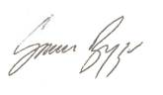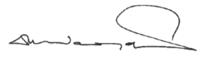Faithfully,

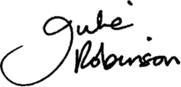

Graeme Biggar

Director General

National Economic Crime Centre

|  |
| --- |
| David Woodgate​ |
| Chief Executive  The Independent Schools' Bursars Association |

Julie Robinson

Chief Executive Officer

Independent Schools Council